1. INVOICE GENERATION – STATEMENT FLOW CONTROL

SOURCE CODE:

# Program 1 - INVOICE GENERATION
print("NAME: Kathirvel")
print("ROLL NO: 12214")
print("CLASS: XII B")
print("NAME OF THE PROGRAM: INVOICE GENERATION USING PYTHON")
print()
prods = int(input("How many products have you purchased? "))
print()
id_ls = []
name_ls = []
qty_ls = []
price_ls = []
dis_ls = []
discount = 0
total = 0
bill = 0
for loop in range(prods):
pname = input(f"Enter the name of the product {loop+1}: ")
pid = 'PDT-' + pname[0].upper() + str(loop)
qty = int(input("Enter its quantity: "))
price = float(input("Enter its price: "))
if price >= 200 and price < 500:
print("This product has a discount of 2 %")
discount = price * 2/100
elif price >= 500 and price < 1000:
print("This product has a discount of 5 %")
discount = price * 5/100
elif price >= 1000 and price < 5000:
print("This product has a discount of 8 %")
discount = price * 8/100
elif price >= 5000:
print("This product has a discount of 10 %")
discount = price * 10/100
else:
discount = 0
name_ls.append(pname)
id_ls.append(pid)
qty_ls.append(qty)
price_ls.append(price)
dis_ls.append(discount)
print()
print("\t\t\tFINAL INVOICE\n")
print("Prod_ID\t\tProd_Name\tQty\tPrice\tDiscount\tTotal")
for loop in range(prods):
total = price_ls[loop] * qty_ls[loop] - dis_ls[loop]
print(f"{id_ls[loop]}\t{name_ls[loop]}\t{qty_ls[loop]}\t{price_ls[loop]}\t{dis_ls[loop]}\t{total}")
bill = bill + total
print(f"\n\t\t\t\tBILL AMOUNT:\t{bill}")

OUTPUT:
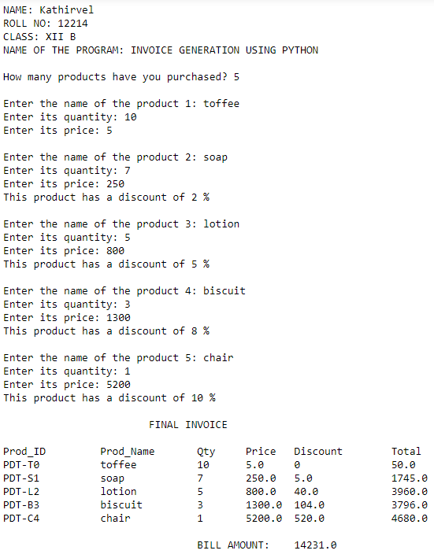
RESULT:
The program is executed successfully.

2. SUM, PRODUCT, SQUARE OF ELEMENTS OF LIST

SOURCE CODE:

# Program 2 - SUM, PRODUCT, SQUARE OF ELEMENTS OF LIST
print("NAME: Kathirvel")
print("ROLL NO: 12214")
print("CLASS: XII B")
print("NAME OF THE PROGRAM: SUM, PRODUCT, SQUARE OF ELEMENTS OF LIST")
print()

Sum = 0
Product = 1
sqlst = []
elems = int(input("Enter the number of elements for the List: "))
List = []

for loop in range(elems):
data = int(input(f"Enter element {loop+1}: "))
List.append(data)
print("Your List -->", List)
print()
for e in List:
Sum = Sum + e
Product = Product * e
Square = e * e
sqlst.append(Square)
print("The Sum of the Elements of your List is:", Sum)
print("The Product of the Elements of your List is:", Product)
print("The Square of the Elements of your List is:", sqlst)

OUTPUT:
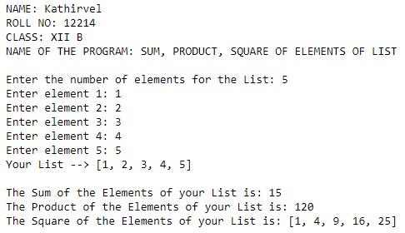
RESULT:
The program is executed successfully.

3. FIBONACCI SERIES

SOURCE CODE:

# Program 3 - FIBONACCI SERIES
print("NAME: Kathirvel")
print("ROLL NO: 12214")
print("CLASS: XII B")
print("NAME OF THE PROGRAM: FIBONACCI SERIES")
print()

def fibonacci(n):
a = 0
b = 1
if n <= 0:
print("Invalid Input !!!")
elif n == 1:
print("Fibonacci Series:\n", a)
else:
print("Fibonacci Series:\n", a, b, end=" ")
for loop in range(n-2):
c = a + b
print(c, end=" ")
a = b
b = c
num = int(input("Enter the number of Fibonacci Series to be generated: "))
fibonacci(num)

OUTPUT:
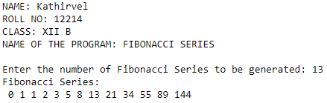
RESULT:
The program is executed successfully.

4. ATM OPERATIONS

SOURCE CODE:

# Program 4 - ATM OPERATIONS
print("NAME: Kathirvel")
print("ROLL NO: 12214")
print("CLASS: XII B")
print("NAME OF THE PROGRAM: ATM OPERATIONS")
print()
Balance = 130000
AcNo = int(input("Enter your Account Number: "))
Name = input("Enter your Name: ")
def Dep():
global Balance
print("\t\tDEPOSIT")
print("\t\t-------")
print("Your Existing Balance is:", Balance)
depamt = int(input("Enter the amount to be deposited: "))
Balance += depamt
print(f"\n\tAmount of Rs.{depamt} is Credited Successfully")
return Balance
def With():
global Balance
print("\t\tWITHDRAWAL")
print("\t\t----------")
print("Your Existing Balance is:", Balance)
withamt = int(input("Enter the amount to be withdrawn: "))
Balance -= withamt
print(f"\n\tAmount of Rs.{withamt} is Debited Successfully")
return Balance
def BalEnq():
print("\n\t\tYour Account Number:", AcNo)
print("\t\tYour Name:", Name)
print("\n\t\tYour Account Balance is:", Balance)
print("\n\t\tWELCOME", Name)
print("\n\t1.Deposit")
print("\t2.Withdrawal")
print("\t3.Balance Enquiry")
print("\t4.Exit\n")
while True:
choice = int(input("Choose your transaction: "))
if choice == 1:
print("\nAccount Number:", AcNo)
print("Name:", Name)
print("\n\tYour Account Balance is:",Dep())
elif choice == 2:
print("\nAccount Number:", AcNo)
print("Name:", Name)
print("\n\tYour Account Balance is:",With())
elif choice == 3:
BalEnq()
elif choice == 4:
break
else:
print("\n!!! CHOOSE A VALID TRANSACTION !!!")
print()
print("\nThank You! visit again!")

OUTPUT:
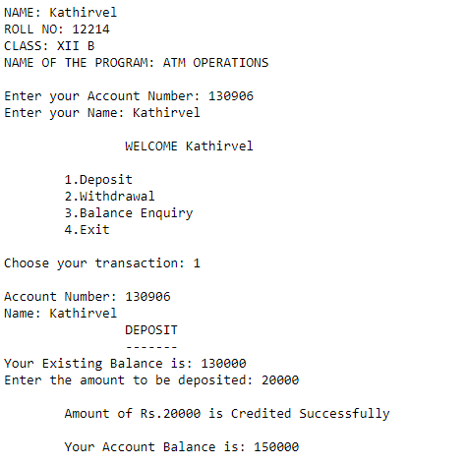

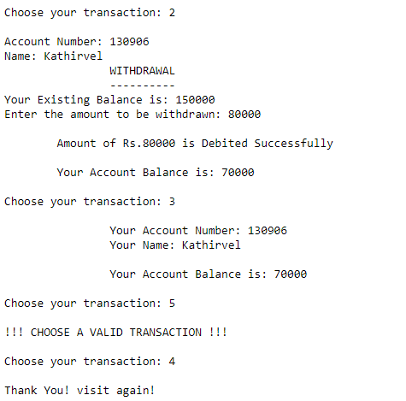
RESULT:
The program is executed successfully.

5. AREA OF SHAPES

SOURCE CODE:

# Program 5 - AREA OF SHAPES
print("NAME: Kathirvel")
print("ROLL NO: 12214")
print("CLASS: XII B")
print("NAME OF THE PROGRAM: AREA OF SHAPES")
print()
print("\t\tAREA OF SHAPES")
print("\t\t--------------")
print("1. Area of Square")
print("2. Area of Rectangle")
print("3. Area of Triangle")
print("4. Area of Circle")
print("5. Exit\n")
choice = int(input("Enter your choice: "))
import math
def square(side):
sqr = side * side
print("The Area of Square:", sqr)
def rectangle(length, breadth):
rect = length * breadth
print("The Area of Rectangle:", rect)
def triangle(base, height):
tri = 0.5 * base * height
print("The Area of Triangle:", tri)
def circle(radius):
circ = math.pi * radius ** 2
print("The Area of Circle:", circ)
while True:
if choice == 1:
s = eval(input("Enter the value of Side: "))
square(s)
elif choice==2:
l = eval(input("Enter the value of Length: "))
b = eval(input("Enter the value of Breadth: "))
rectangle(l,b)
elif choice == 3:
bse = eval(input("Enter the value of Base: "))
h = eval(input("Enter the value of Height: "))
triangle(bse,h)
elif choice == 4:
r = eval(input("Enter the value of Radius: "))
circle(r)
elif choice == 5:
break
else:
print("INVALID SELECTION!!!")
print()
choice = int(input("Enter your choice: "))

OUTPUT:
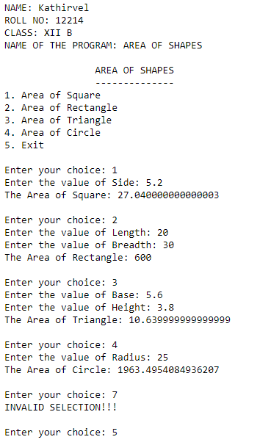
RESULT:
The program is executed successfully.
6. RANDOM GENERATOR (DICE GAME)

SOURCE CODE:

# Program 6 - RANDOM GENERATOR (DICE GAME)
print("NAME: Kathirvel")
print("ROLL NO: 12214")
print("CLASS: XII B")
print("NAME OF THE PROGRAM: RANDOM GENERATOR (DICE GAME)")
print()

import random
print("\t\tDICE GAME")
print("\t\t*********")
moves = int(input("How many moves do you want to play? "))

for loop in range(moves):
print("\nMove", loop+1)
print("\tYour Turn")
print("\t---------")
key = input("Press any key to roll the dice (Press Enter to skip)... ")
if key:
print("You -->", random.randint(1,6))
else:
print("Skipped...")
print("\tComputer's Turn")
print("\t---------------")
print("Computer -->", random.randint(1,6))

OUTPUT:
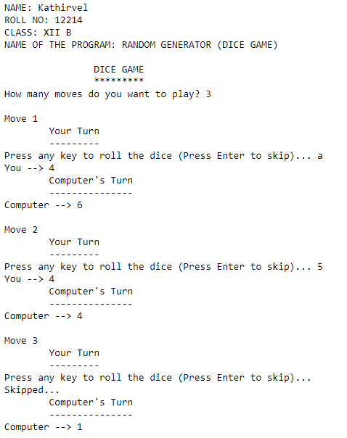
RESULT:
The program is executed successfully.

7. COUNTING CHARACTERS, WORDS AND LINES

SOURCE CODE:

# Program 7 - COUNTING CHARACTERS, WORDS AND LINES
print("NAME: Kathirvel")
print("ROLL NO: 12214")
print("CLASS: XII B")
print("NAME OF THE PROGRAM: COUNTING CHARACTERS, WORDS AND LINES")
print()

file = open("Introduction_to_Python.txt","w+")
file.write('''Introduction to Python
1. Python is a high-level programming language known for its readability and simplicity.
2. Created by Guido van Rossum in the late 1980s, Python is continuously developed and maintained.
3. Python emphasizes clean and readable code, enhancing collaboration and ease of learning for beginners.
4. It supports multiple programming paradigms, including procedural, object-oriented, and functional programming.
5. Python boasts a comprehensive standard library, providing ready-to-use modules for various tasks.
6. It is widely used in web development, data science, artificial intelligence, and automation.
7. Python's large and active community contributes to its wealth of resources,
making it a preferred language for developers worldwide.''')

file.seek(0)
data = file.read()
num_of_char = len(data)
num_of_words = len(data.split())
num_of_lines = len(data.splitlines())
print("Number of characters is:", num_of_char)
print("Number of words is:", num_of_words)
print("Number of lines is:", num_of_lines)
file.close()

OUTPUT:

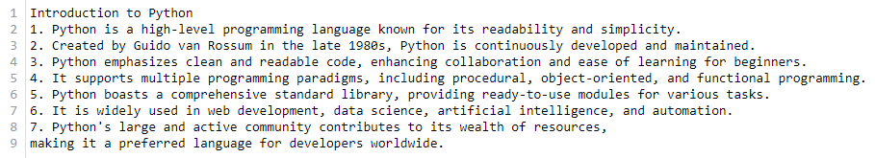
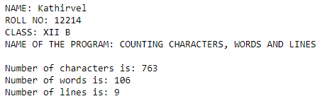
RESULT:
The program is executed successfully.

8. REMOVING LINES CONTAINING 'a'

SOURCE CODE:

# Program 8 - REMOVING LINES CONTAINING 'a'
print("NAME: Kathirvel")
print("ROLL NO: 12214")
print("CLASS: XII B")
print("NAME OF THE PROGRAM: REMOVING LINES CONTAINING 'a'")
print()

rfile = open("Self_Discovery.txt","r+")
data = rfile.read()
print("The Original File Content:\n\n" + data)
print()
with open("Self_Discovery.txt","w+") as wfile:
for line in data.splitlines():
if 'a' not in line:
wfile.write(line)
wfile.write("\n")
wfile.seek(0)
content = wfile.read()
print("The file content after removing lines containing 'a':\n\n" + content)

OUTPUT:

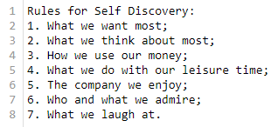

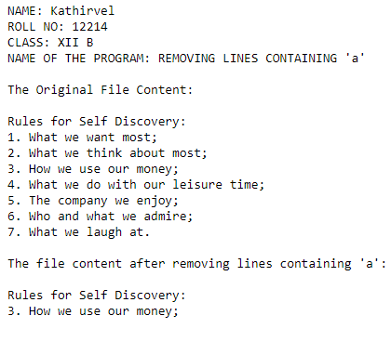
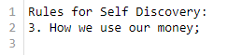
RESULT:
The program is executed successfully.

9. WORDS SEPARATOR BY '#'

SOURCE CODE:

# Program 9 - WORDS SEPARATOR BY '#'
print("NAME: Kathirvel")
print("ROLL NO: 12214")
print("CLASS: XII B")
print("NAME OF THE PROGRAM: WORDS SEPARATOR BY '#'")
print()

w_fle = open("Python.txt","w")
w_fle.write('''This is Data File Handling. Two Data Files are Text File and Binary File.''')
w_fle.flush()
with open("Python.txt","r") as r_fle:
sent = r_fle.read()
print("Original File Content:")
print(sent)
print("Words separated by '#':")
for loop in range(len(sent)):
if sent[loop].isspace():
print('#', end='')
else:
print(sent[loop], end='')

OUTPUT:
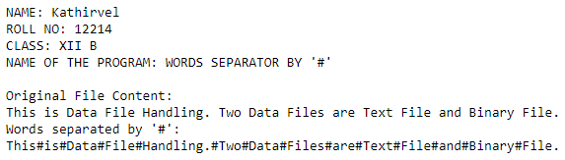
RESULT:
The program is executed successfully.

10. SEARCHING IN A BINARY FILE

SOURCE CODE:

# Program 10 - SEARCHING IN A BINARY FILE
print("NAME: Kathirvel")
print("ROLL NO: 12214")
print("CLASS: XII B")
print("NAME OF THE PROGRAM: SEARCHING IN A BINARY FILE")
print()

import pickle
students = []
num = int(input("How many records you want to enter: "))
for loop in range(num):
rno = int(input(f"\nEnter the Roll Number of the Student {loop+1}: "))
name = input(f"Enter the Name of the Student {loop+1}: ")
cls = int(input(f"Enter the Class of the Student {loop+1}: "))
rec = [rno,name,cls]
students.append(rec)
with open("Students_Data.dat","wb+") as f:
pickle.dump(students,f)
f.seek(0)
ls = pickle.load(f)
search = int(input("\nEnter the Roll Number of the Student you want to search: "))
for row in ls:
if row[0] == search:
print("\nRecord found...", row, sep="\n")
break
else:
print("\nRecord Not Found")

OUTPUT:

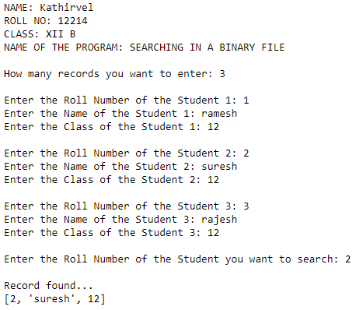
RESULT:
The program is executed successfully.

11. UPDATING BINARY FILE

SOURCE CODE:

# Program 11 - UPDATING BINARY FILE
print("NAME: Kathirvel")
print("ROLL NO: 12214")
print("CLASS: XII B")
print("NAME OF THE PROGRAM: UPDATING BINARY FILE")
print()

import pickle
marklist = []
num = int(input("How many records you want to enter: "))
for loop in range(num):
rno = int(input(f"\nEnter the Roll Number of the Student {loop+1}: "))
name = input(f"Enter the Name of the Student {loop+1}: ")
mark = float(input(f"Enter the Mark of the Student {loop+1}: "))
det = [rno,name,mark]
marklist.append(det)
with open("Mark_List.dat","wb+") as bfile:
pickle.dump(marklist,bfile)
bfile.seek(0)
mlst = pickle.load(bfile)
print("\nOld Mark List:", mlst, sep="\n")
srh = int(input("\nEnter the Roll Number of the Student whose mark is to be updated: "))
for rec in mlst:
if rec[0] == srh:
new = float(input(f"Enter the New Mark of the Student: "))
rec[2] = new
bfile.seek(0)
pickle.dump(mlst,bfile)
bfile.seek(0)
updlst = pickle.load(bfile)
print("Mark List Updated...")
print(updlst)
break
else:
print("Record Not Found...")

OUTPUT:

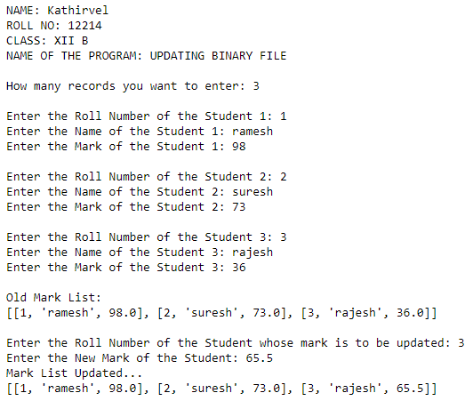
RESULT:
The program is executed successfully.

12. CREATING CSV FILE FOR STORING INVENTORY RECORDS

SOURCE CODE:

# Program 12- CREATING CSV FILE
print("NAME: Kathirvel")
print("ROLL NO: 12214")
print("CLASS: XII B")
print("NAME OF THE PROGRAM: CREATING CSV FILE")
print()

import csv
invntry = {}
stkno = []
stkname = []
qty = []
choice = 'Y'
print("\t\tINVENTORY")
print("\t\t*********")
while choice.upper() == 'Y':
sno = int(input("Enter the Stock Serial Number: "))
name = input("Enter the Stock Name: ")
q = int(input("Enter the Quantity: "))
stkno.append(sno)
stkname.append(name)
qty.append(q)
print()
choice = input("Do you want to continue?(Y/N): ")
invntry.update(StockNo=stkno, StockName=stkname, Quantity=qty)

with open("Inventory.csv", "w+", newline="\n") as cfile:
w = csv.writer(cfile)
w.writerow(invntry.keys())
for loop in range(len(stkno)):
w.writerow([invntry['StockNo'][loop],invntry['StockName'][loop],invntry['Quantity'][loop]])
r = csv.reader(cfile)
cfile.seek(0)
for row in r:
print(row)

OUTPUT:
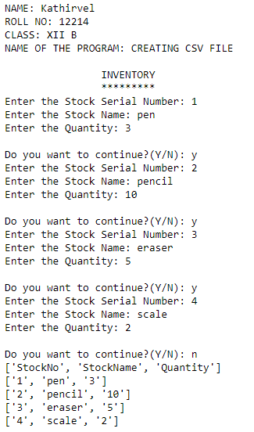
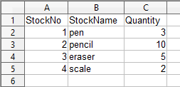
RESULT:
The program is executed successfully.

13. 2D LIST (MATRIX) CREATION

SOURCE CODE:

# Program 13 - 2D LIST (MATRIX) CREATION
print("NAME: Kathirvel")
print("ROLL NO: 12214")
print("CLASS: XII B")
print("NAME OF THE PROGRAM: 2D LIST (MATRIX) CREATION")
print()
cols = int(input("Enter the number of columns you need: "))
rows = int(input("Enter the number of rows you need: "))
column = []
for r in range(rows):
row = []
for c in range(cols):
rowelem = eval(input(f"Enter the value for row {r+1} and column {c+1}: "))
row.append(rowelem)
column.append(row)
print()
print("Your 2D List:")
print(column)

OUTPUT:
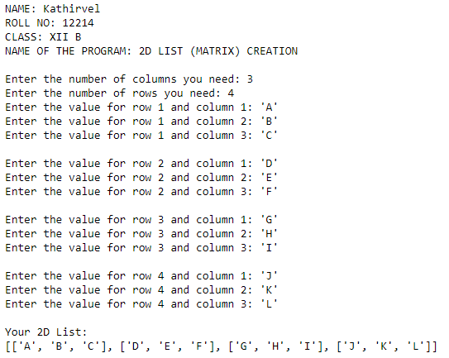
RESULT:
The program is executed successfully.
14. STACK OPERATIONS

SOURCE CODE:

# Program 14 - STACK OPERATIONS
print("NAME: Kathirvel")
print("ROLL NO: 12214")
print("CLASS: XII B")
print("NAME OF THE PROGRAM: STACK OPERATIONS")
print()
def Push(stk, elem):
stk.append(elem)
top = len(stk) - 1
def Pop(stk):
if stk == []:
return 'Underflow'
else:
del_elem = stk.pop()
if len(stk) == 0:
top = None
else:
top = len(stk) - 1
return del_elem
def Peek(stk):
if stk == []:
return 'Underflow'
else:
top = len(stk) - 1
return stk[top]
def Display(stk):
if stk == []:
print("\n\tStack is Empty !")
else:
top = len(stk) - 1
print("\nStack contains:")
print("\t", stk[top], "<- Top element")
for loop in range(top-1, -1, -1):
print("\t", stk[loop])
Stack = []
top = None
while True:
print("\n\t\tSTACK OPERATIONS")
print("\t\t****************")
print("1.Push")
print("2.Pop")
print("3.Peek")
print("4.Display")
print("5.Exit")
ch = int(input("Enter your choice: "))
if ch < 1 or ch > 5:
print("\n!!! INVALID SELECTION !!! Choose from 1 to 5")
elif ch == 1:
Element = int(input("Enter the element: "))
Push(Stack, Element)
elif ch == 2:
d_elem = Pop(Stack)
if d_elem == 'Underflow':
print("\n\tUnderflow ! The Stack is Empty")
else:
print("\n\tThe Popped element is:", d_elem)
elif ch == 3:
top_elem = Peek(Stack)
if top_elem == 'Underflow':
print("\n\tUnderflow ! The Stack is Empty")
else:
print("\n\tThe Topmost element is:", top_elem)
elif ch == 4:
Display(Stack)
elif ch == 5:
break
print("Thank You!")

OUTPUT:

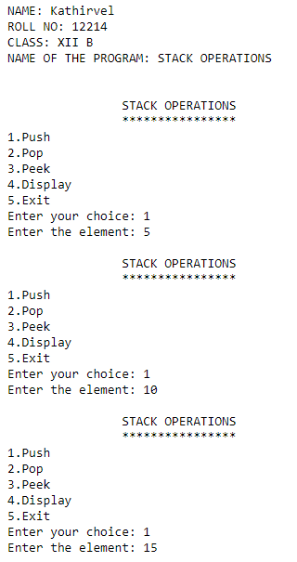
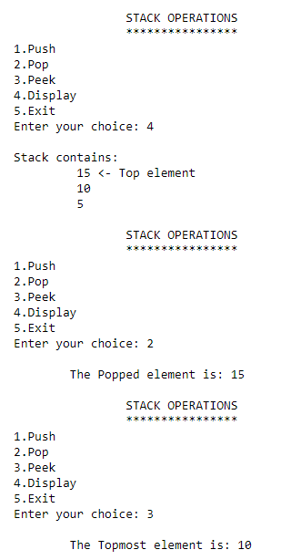
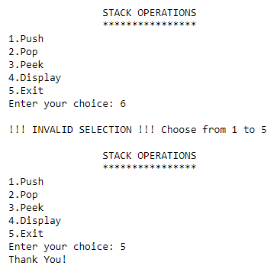
RESULT:
The program is executed successfully.

15. LINEAR SEARCH

SOURCE CODE:

# Program 15 - LINEAR SEARCH
print("NAME: Kathirvel")
print("ROLL NO: 12214")
print("CLASS: XII B")
print("NAME OF THE PROGRAM: LINEAR SEARCH")
print()

def LinearSearch(lst, key):
found = None
for loop in range(len(lst)):
if lst[loop] == key:
found = lst.index(lst[loop])
if found == None:
return -1
else:
return found

ls = eval(input("Enter the list: "))
opt = 'Y'
if type(ls) == tuple:
print("\t!!! ENTER THE ELEMENTS IN SQUARE BRACKETS[] !!!")
else:
while opt == 'Y' or opt == 'y':
search = int(input("\nEnter the element to be searched: "))
ind = LinearSearch(ls,search)
if ind == -1:
print("\n\tSorry! Element is not in the List")
else:
print(f"\n\tThe Element {search} is found at Index Position {ind}")
opt = input("\nDo you want to search any other elements? (Y/N): ")

OUTPUT:

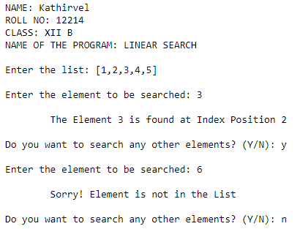
RESULT:
The program is executed successfully.

16. BINARY SEARCH

SOURCE CODE:

# Program 16 - BINARY SEARCH
print("NAME: Kathirvel")
print("ROLL NO: 12214")
print("CLASS: XII B")
print("NAME OF THE PROGRAM: BINARY SEARCH")
print()

def BinarySearch(lst,key):
beg = 0
last = len(ls) - 1
while beg <= last:
mid = (beg+last) // 2
if search == ls[mid]:
return mid
elif search > ls[mid]:
beg = mid+1
elif search < ls[mid]:
last = mid - 1
else:
return -1

ls = eval(input("Enter the list: "))
opt = 'y'
if type(ls) == tuple:
print("\t!!! ENTER THE ELEMENTS IN SQUARE BRACKETS[] !!!")
else:
while opt.lower() == 'y':
ls.sort()
print("The Sorted List:", ls)
search = int(input("\nEnter the element to be searched: "))
ind = BinarySearch(ls,search)
if ind == -1:
print("\n\tSorry! Element is not in the List")
else:
print(f"\n\tThe Element {search} is found at Index Position {ind}")
opt = input("\nDo you want to search any other elements? (Y/N): ")

OUTPUT:

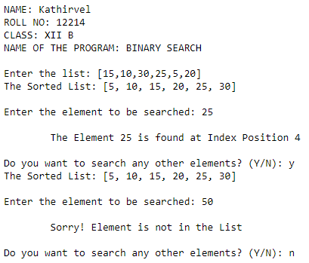
RESULT:
The program is executed successfully.

17. GENERATING CREATE, INSERT QUERIES - PYTHON MYSQL INTERFACE

SOURCE CODE:

# Program 17 - GENERATING CREATE, INSERT QUERIES - PYTHON MYSQL INTERFACE
print("NAME: Kathirvel")
print("ROLL NO: 12214")
print("CLASS: XII B")
print("NAME OF THE PROGRAM: GENERATING CREATE, INSERT QUERIES - PYTHON MYSQL INTERFACE")
print()

import mysql.connector as sql
conn = sql.connect(host="localhost", user="root", password="kathir13", database="Class12CS")
if conn.is_connected():
print("Connection Established Successfully... Process Started...")
crsr = conn.cursor()
create = '''CREATE TABLE Student
(RollNo VARCHAR(20), Name CHAR(20), DOB DATE, PhoneNo BIGINT, Location VARCHAR(30))'''
crsr.execute(create)
conn.commit()
print("Student Table is Created Successfully...")
print("\tEnter Data for the Table Student:")
rec = int(input("How many records do you want to insert in the Table Student? "))
print()
for loop in range(rec):
rno = input(f"Enter the Roll Number of the Student {loop+1}: ")
name = input(f"Enter the Name of the Student {loop+1}: ")
dob = int(input(f"Enter the DOB of the Student {loop+1} in YYYYMMDD format: "))
phone = int(input(f"Enter the Phone Number of the Student {loop+1}: "))
loc = input(f"Enter the Location of the Student {loop+1}: ")
crsr.execute(f"INSERT INTO Student VALUES('{rno}','{name}',{dob},{phone},'{loc}')")
conn.commit()
print(f"\t{loop+1} Records Inserted Successfully...\n")
conn.close()

OUTPUT:
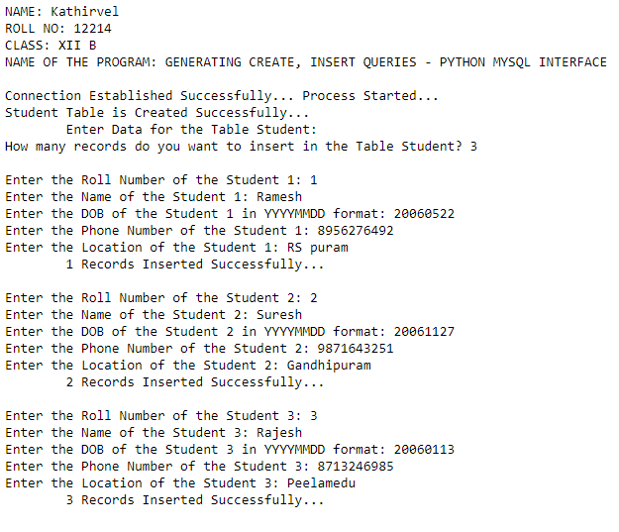
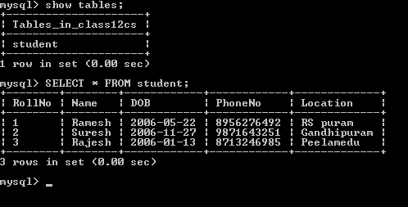
RESULT:
The program is executed successfully.

18. GENERATING UPDATE, DELETE QUERIES - PYTHON MYSQL INTERFACE

SOURCE CODE:

# Program 18 - GENERATING UPDATE, DELETE QUERIES - PYTHON MYSQL INTERFACE
print("NAME: Kathirvel")
print("ROLL NO: 12214")
print("CLASS: XII B")
print("NAME OF THE PROGRAM: GENERATING UPDATE, DELETE QUERIES - PYTHON MYSQL INTERFACE")
print()

import mysql.connector as sql
conn = sql.connect(host="localhost", user="root", password="kathir13", database="Class12CS")
if conn.is_connected():
print("Connection Established Successfully... Process Started...\n")
crsr = conn.cursor()
print("\tUPDATE STUDENT PHONE NUMBER...")
ch = input("\nDo You Want To Update Phone No. of Any Record?(Y/N): ")
while ch == 'Y' or ch == 'y':
name = input("\nEnter the Name of the Student: ")
phone = int(input(f"Enter the New Phone Number of {name}: "))
crsr.execute(f"UPDATE Student SET PhoneNo={phone} WHERE Name='{name}'")
conn.commit()
print(f"\n\t{name} Phone Number is Updated to {phone} Successfully...")
ch = input("\nDo You Want To Update Phone No. of Any Other Record?(Y/N): ")

print("\n\tDELETE STUDENT RECORD...")
ch1 = input("\nDo You Want To Delete Any Record?(Y/N): ")
while ch1 == 'Y' or ch1 == 'y':
rno=input("\nEnter the Roll Number of the Student: ")
crsr.execute(f"DELETE FROM Student WHERE RollNo='{rno}'")
conn.commit()
print(f"\n\t{rno} Record is Deleted Successfully...")
ch1 = input("\nDo You Want To Delete Any Other Record?(Y/N): ")
conn.close()

OUTPUT:
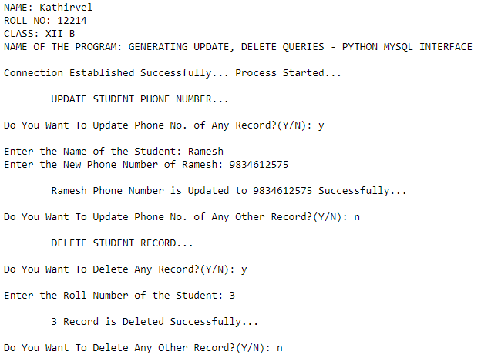
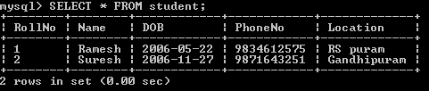
RESULT:
The program is executed successfully.

19. GENERATING SELECT QUERY - PYTHON MYSQL INTERFACE

SOURCE CODE:

# Program 19 - GENERATING SELECT QUERY - PYTHON MYSQL INTERFACE
print("NAME: Kathirvel")
print("ROLL NO: 12214")
print("CLASS: XII B")
print("NAME OF THE PROGRAM: GENERATING SELECT QUERY - PYTHON MYSQL INTERFACE")
print()

import mysql.connector as sql
conn = sql.connect(host="localhost", user="root", password="kathir13", database="Class12CS")
if conn.is_connected():
print("Connection Established Successfully... Process Started...\n")
crsr = conn.cursor()
select = "SELECT * FROM Student ORDER BY DOB"
crsr.execute(select)
table = crsr.fetchall()
count = crsr.rowcount
print(f"The Number of Records retrieved are: {count}")
print("The Records in the Table Student:")
for row in table:
print(row)

ch = input("\nDo You Want To Retrieve Any Specific Number Of Records?(Y/N): ")
while ch.upper() == 'Y':
rec = int(input("\nHow many Records do you need? "))
crsr.execute(select)
data = crsr.fetchmany(rec)
count2 = crsr.rowcount
print(f"\nThe Number of Records now retrieved are: {count2}")
print(f"{rec} Records from the Table Student:")
for record in data:
print(record)
ch = 'N'
conn.close()

OUTPUT:

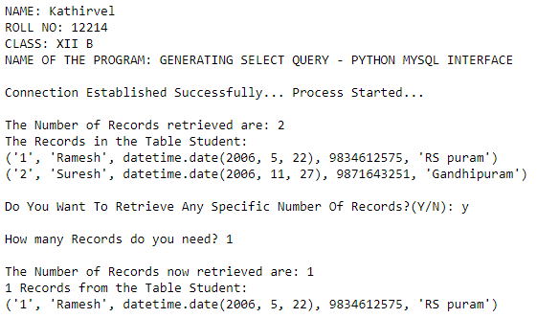
RESULT:
The program is executed successfully.

20. GENERATING ALTER QUERY - PYTHON SQL INTERFACE

SOURCE CODE:

# Program 20 - GENERATING ALTER QUERY - PYTHON SQL INTERFACE
print("NAME: Kathirvel")
print("ROLL NO: 12214")
print("CLASS: XII B")
print("NAME OF THE PROGRAM: GENERATING ALTER QUERY - PYTHON SQL INTERFACE")
print()
import mysql.connector as sql
conn = sql.connect(host="localhost", user="root", password="kathir13", database="Class12CS")
if conn.is_connected():
print("Connection Established Successfully... Process Started...")
crsr = conn.cursor()
print("\n\tAlter Operations for the Table Student")
print("\n1.Add New Column")
print("2.Modify Existing Column")
print("3.Rename Column")
print("4.Exit\n")
ch = int(input("Select The Operation You Want To Perform: "))
while True:
if ch == 1:
newcol = input("\nEnter the New Column Name: ")
newdat = input(f"Enter the DataType with Size(if any) for {newcol}: ")
crsr.execute(f"ALTER TABLE Student ADD {newcol} {newdat}")
conn.commit()
print("\n\tAdded a New Column Successfully...")
elif ch == 2:
col = input("\nEnter the Column Name to be Modified: ")
chdat = input(f"Enter the New DataType with New Size(if any) for {col}: ")
crsr.execute(f"ALTER TABLE Student MODIFY {col} {chdat}")
conn.commit()
print(f"\n\tModified {col} Successfully...")
elif ch == 3:
oldname = input("\nEnter the Column Name to be Renamed: ")
newname = input(f"Enter the New Column Name with New Size(if any) for {oldname}: ")
crsr.execute(f"ALTER TABLE Student CHANGE {oldname} {newname}")
conn.commit()
print(f"\n\tRenamed {oldname} Successfully...")
elif ch == 4:
break
else:
print("!!! CHOOSE A VALID OPERATION !!!")
ch = int(input("\nSelect The Operation You Want To Perform: "))
conn.close()

OUTPUT:
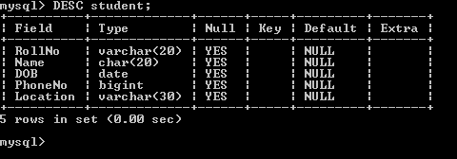
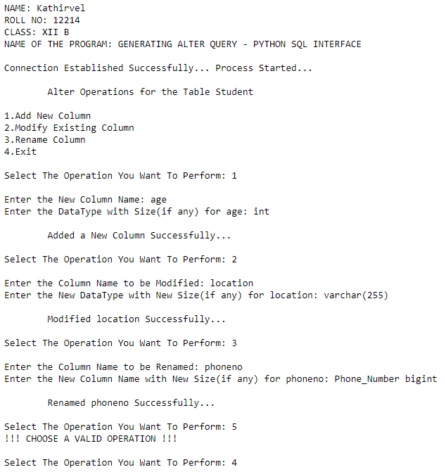
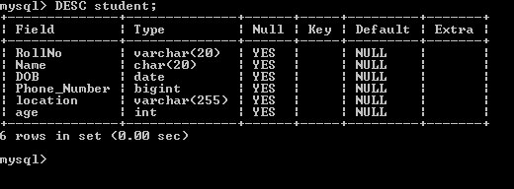
RESULT:
The program is executed successfully.

